BANK TOPICS
CHRISTMAS NEWSLETTER 2020

A Christmas message from our Partnership Minister, Jacky

Dear friends and friends to be,
This will be a Christmas like no other, but the essence remains the same. We are celebrating the fact that God loves us so much that Jesus was born among us, into poverty and danger.
What is missing, or rather greatly decreased, is our interaction with others: family, friends, neighbours, and strangers. We’ve had to work to keep up our relationships this year and we’ve not been able to make new ones in the usual ways.
As Christians, we are called to pass on the good news that God loves us, as well as sharing that love in practical ways. This has to be through relationships old and new. I’m hoping to learn from this year, so my New Year’s resolution is to be as deliberate next year about making and keeping up relationships, as I have had to be this year.
Once we can meet more normally again, let’s see if we can all be deliberate about making new relationships, as well as building on those we already have. Let’s also be intentional in sharing God’s love with all those we encounter. Then we will be able to share next Christmas with more folk than ever.
May God grant you both joy and peace this Christmas,
Jacky

Hi everyone, from your Church Secretary

We are coming to the end of 2020, and most of us will be glad to see the back of it. What a year it’s been! In January most of us had never heard of Furlough, Zoom, Teams, and Blended Learning, and now for many they are all part of our everyday language!!

Looking at the past year, little did we know what was in store for us all. To say it’s been challenging is a bit of an understatement. We’ve all faced uncertainly with lockdowns and many people facing a balancing act with home schooling, working from home, being in the front line as key workers and having jobs put at risk. Others, who live alone have faced long periods of isolation. It’s at times like this that we can see and feel how strong our church community is, and how much we all rally round and look after each other. Our church continues to show a real determination and resilience, and it’s all been down to each and every one of you.

From the middle of March, when we first went into lockdown and church was closed, it was very difficult for us; not being able to worship together each Sunday morning. But it wasn’t very long before we began to think outside the box, and Andy set up the Sunday morning Zoom services. A huge thank you to Andy (and Heather) for all they did to make that possible. And without the Zoom services, then we wouldn’t have found our very talented ‘Celestial choir.’ And it was great to see members of Egerton URC joining us each Sunday, and we got to know them really well. In the middle of August, when churches could once again open their doors (to very limited numbers), Bank Top was one of the first churches to re-open, and this worked really well for the older people who couldn’t get on-line, and were desperate to get back. And connecting via the screen to those on Zoom each Sunday was such a great feeling for us all. And it was good to reopen Sunday school. And then came the second lock down! . . . but we were much better prepared this time around.

And now, as Christmas is almost upon us – and we will all be celebrating in a different way than normal, let’s remember the message in the Christmas Card that has been circulated and the banners and posters on buses throughout the town – ‘Christmas may seem different this year, but the story is still the same.’ And this year, even more importantly, let us think about that story that remains the same; Jesus came to us as a baby, to grow and experience every emotion that we go through as he lived amongst his people. And that he gave his life for us when he was crucified. But his Holy Spirit still lives on within us; and that is definitely a cause for celebration this year.

It’s not been an easy year, and some of us will have lost family and friends to the Corona virus, and we remember these people in our hearts, and we continue to pray for all those who have lost loved ones, whose Christmas this year will not be the same.

Thank you to our Elders, who have been meeting on-line throughout the year, to make sure things still continue to run smoothly. Thank you to Andy for leading most of our services; thank you to Carol and Maureen who have continued to put flowers into church and take them out to people, and thank you to those who have given money for the purchase of the flowers. Thank you to all our Carers, who have kept in touch with people on their lists; thank you to Christine Counsell, who always works quietly behind the scenes making sure that our building is safe and warm and well equipped. And if I have missed out anyone else, then I apologise.

Let’s all look to 2021, to the vaccination that hopefully we will all receive, and getting back to – maybe not the old normal, but at least one that is a little more normal than now!

Val

And now a message from me with a different hat on . . . as your Church Treasurer
At the start of lockdown, we were required by NW Synod to send an estimate of what we expected our losses to be in 2020. I had a close look at our situation – and with the ceasing of all our weekly lettings and loss off weekly offerings, I estimated our losses to be in the region of £10,000.

However, this has not proved to be the case, and this is really down to the generosity of all of you, our church members. So, I would like to say a huge, big, enormous, thank you to everyone. It has been very humbling for me as your treasurer to experience the absolute dedication from you all. Yes, we missed the Village Fair, yes we missed the Advent Brunch, yes we missed all the Monthly Brunches and yes all of our Lettings were cancelled, but our losses have not been half as bad as anticipated. In fact, our, or rather should I say, your weekly and monthly offerings have actually exceeded last year!! I have had members paying directly into our bank; others knocking at my door with their envelopes; cheques sent in the post and donations too. My most recent calculations to NW Synod were that our losses would be just over £7,000, and I am pleased to report that we have received a donation from Synod of £7,100 to cover our losses, and for which we are extremely grateful. This means that by the end of the year I am expecting that our final balance will be up from the start of the year – incredible!!

And there is more good news! . . . NW Synod have reduced our Ministry and Mission contributions for 2021 by 25%. Thank you NW Synod!

In addition, I must thank everyone for your giving to Charities throughout the year; we gave a cheque to Bolton Hospice for £222 at Harvest time; a cheque to Bolton Lions for £282 for their annual Christmas toy appeal and £450 to Zac’s Youth Bars – our chosen charity for the year.

If anyone still has envelopes for this year, can you please try to get them to me before the end of December. I have next year’s envelopes ready and I will try to deliver them before Christmas. Subscriptions to our 50/50 for 2021 are now due and I would like to thank those people who have already let me have theirs.

Once again, thank you to everyone for all your support this year and I look forward to 2021 when Sunday Services will resume for everyone, when we will really appreciate singing together, our lettings will once again fill the hall with friendship and laughter and the Village Fair will be bigger and better than ever!

Merry Christmas and a Peaceful New Year, Val

Bible Readings
3rd January Matthew 2:1-12 | 7th February 1 Corinthians 9:16-23
10th January Mark 1:4-11 | 14th February Mark 9:2-9
17th January John 1:43-51 | 21st February Mark 1:9-15
24th January Mark 1:14-20 | 28th February Mark 8:31-38
31st January Mark 1:21-28

Christmas Card Time…
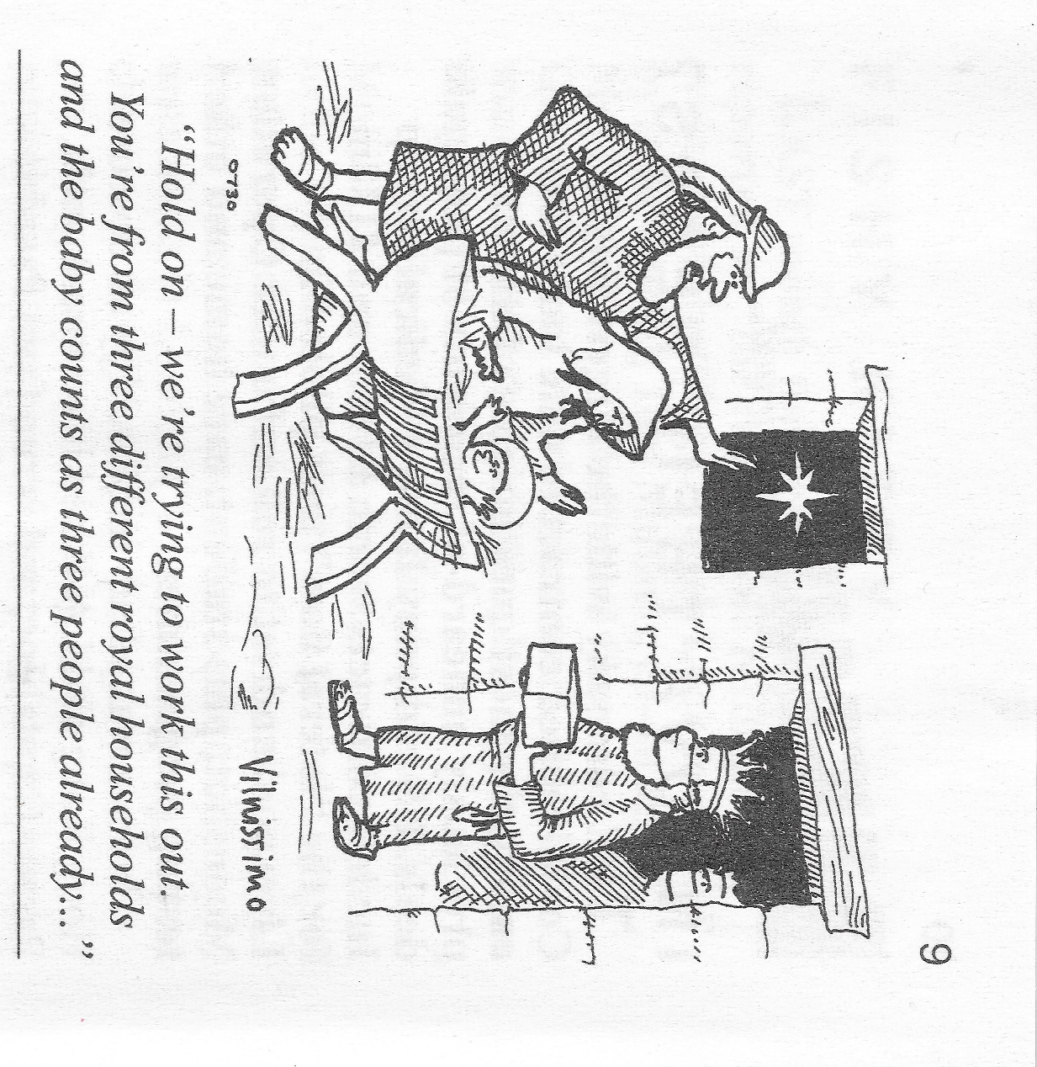
God Bless you all and may you be watched over in the months ahead. As those song goes…

Things can only get better!!!!
Heather and Andy
(And thank God for Private Eye, spot the page number!)
SEVEN REASONS NOT TO MESS WITH CHILDREN
A little girl was talking to her teacher about whales.
The teacher said it was physically impossible for a whale to swallow a human
because even though it was a very large mammal its throat was very small.
The little girl stated that Jonah was swallowed by a whale.
Irritated, the teacher reiterated that a whale could not swallow a human;
It was physically impossible.
The little girl said, 'When I get to heaven I will ask Jonah'.
The teacher asked, 'What if Jonah went to hell?'
The little girl replied, 'Then you ask him'.
A Kindergarten teacher was observing her classroom of children while they were drawing..
She would occasionally walk around to see each child's work.
As she got to one little girl who was working diligently, she asked what the drawing was.
The girl replied, 'I'm drawing God.'
The teacher paused and said, 'But no one knows what God looks like'.
Without missing a beat, or looking up from her drawing, the girl replied, 'They will in a minute'.
A Sunday school teacher was discussing the Ten Commandments with her five and six year olds.
After explaining the commandment to 'Honour' thy Father and thy Mother, she asked, 'Is there a commandment that teaches us how to treat our brothers and sisters?'
Without missing a beat one little boy (the oldest of a family) answered, 'Thou shall not kill.'
One day a little girl was sitting and watching her mother do the dishes at the kitchen sink.
She suddenly noticed that her mother had several strands of white hair sticking out in contrast on her brunette head.
She looked at her mother and inquisitively asked, 'Why are some of your hairs white, Mum?'
Her mother replied, 'Well, every time that you do something wrong and make me cry or unhappy,
one of my hairs turns white.'
The little girl thought about this revelation for a while and then said,
'Mummy, how come ALL of grandma's hairs are white?'
The children had all been photographed, and the teacher was trying to persuade them each to buy a copy of the group picture.
'Just think how nice it will be to look at it when you are all grown up andsay, 'There's Jennifer, she's a lawyer,' or 'That's Michael, He's a doctor.'
A small voice at the back of the room rang out, 'And there's the teacher, she's dead.'
A teacher was giving a lesson on the circulation of the blood.
Trying to make the matter clearer, she said,
'Now, class, if I stood on my head, the blood, as you know, would run into it, and I would turn red in the face.'
'Yes,' the class said. Then why is it that while I am standing upright in the ordinary position the blood doesn't run into my feet?'
A little fellow shouted, 'Cause your feet ain't empty'.
The children were lined up in the cafeteria of a Catholic Elementary School for lunch.
At the head of the table was a large pile of apples.. The nun made a note, and posted on the apple tray:
'Take only ONE. God is watching.'
Moving further along the lunch line, at the other end of the table was a large pile of chocolate chip cookies.
A child had written a note, 'Take all you want. God is watching the apples.'

Try these Christmas Dingbat and see how you get on. The secret is – say what you see!

CHRISTMAS DINGBATS
1 | 2 | 3
4 | 5 | 6
7 | 8
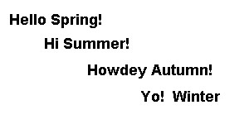
10 | 11 | 12
 | 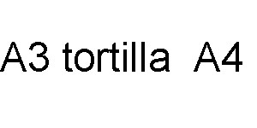
13 | 14 | 15

Answers at the end of the Newsletter. Don’t cheat!!

BANK TOP URC FLOWER LIST 2021

JAN 2021 | NAME | FEB 2021 | NAME | MAR 2021 | NAME
3rd | Andy & Heather Guthrie | 7th | Jill Partington | 7th | Joan Seddon
10th | Ali Spence | 14th | The Owens | 14th | Sarah Astley
17th | Pat McNulty | 21st | In Memory of Phyllis Walsh | 21st | In Memory of Clarice Bickerstaff
24th | Christine Counsell | 28th | Val Singleton | 28th | Barbara Harper
31st | VACANT
APRIL 2021 | NAME | MAY 2021 | NAME | JUNE 2021 | NAME
4th | Andy & Heather Guthrie | 2nd | In Memory of Lilian & Alan Tredrea | 6th | Christine Counsell
11th | Linda Rainford | 9th | Maureen & Syd Roocroft | 13th | Muriel Brown
18th | Sue Seddon | 16th | SERMONS – The Guides | 20th | Sarah Astley
25th | Christine Catherall | 23rd | Maureen Flitcroft | 27th | Maureen Flitcroft
 |  | 30th | VACANT
JULY 2021 | NAME | AUG 2021 | NAME | SEPT 2021 | NAME
4th | Mr & Mrs Warburton | 1st | Andy & Heather Guthrie | 5th | Vicky Constantine
11th | Jill Partington | 8th | Ann, Alex, Carol & Jess | 12th | Jean Short
18th | In Memory of  Gladys Yates | 15th | Phil Seddon | 19th | In Memory of Phyllis Walsh
25th | Kath Dean | 22nd | Margaret Taylor &  Ruth Butcher | 26th | Val & Jill
 |  | 29th | David Canham
OCT 2021 | NAME | NOV 2021 | NAME | DEC 2021 | NAME
3rd | Ann & Richard Smith | 7th | Marian & Harry Batty
10th | Vicky Constantine | 14th | Muriel Brown | 5th | Pauline Birch
17th | In Memory of Clarice Bickerstaff | 21st | Julie Skidmore | 12th | Christine Catherall
24th | In Memory of  Kath Tyldesley | 28th | Ali Spence | 19th | Maureen & Syd Roocroft
31st | Ann, Alex, Carol & Jess |  |  | 26th | Kath Blake

If you would like to put flowers in Church please put your name on the list against a vacant Sunday or speak to Maureen Flitcroft or Carol Rideout. If you know of anyone who’s unwell, feeling down or just needs cheering up please let Maureen, Carol, Church elder or anyone in church know on Sunday and we’ll ensure that they get flowers from the communion table.
If you no longer wish to be on the flower list please cross off your name or either speak to/contact Maureen or Carol
Contact numbers for Maureen is 01204 301328 and Carol is 01204 596360.

A Christmas Bible Quiz
Answers at the end of the Newsletter

Questions:

Joseph and Mary
1 Who told Mary and Joseph to go to Bethlehem?
2 True or False: Mary and Joseph went to Bethlehem for the birth of Jesus because they were following a star.
3 What form of transportation did Mary and Joseph use to get to Bethlehem? The answer is not a taxi cab.

Jesus
4 Which Old Testament prophet had the most to say about the birth of Christ?
5 In the accounts announcing the birth of Christ (Matthew 1 and Luke 1 and 2) how many times did an angel or angels appear?
6 Who told Joseph the baby’s name was to be Jesus?
7 Can you list 5 names of Jesus found in the Bible? Some on my list are from Old Testament prophecies.
8 What are the meanings of the names Jesus and Emmanuel?

Shepherds and Wise Men
9 The shepherds and the wise men went to see Jesus. Which group followed a star and which group went to find the baby because an angel told them where to look?
10 What did the angels sing to the shepherds?
11 When the shepherds went looking for Jesus, what was the sign they were to look for?
12 How many wise men or kings or magi came to see Jesus?
13 Matthew 2:8 says that Herod asked the wise men to inform him where the baby Jesus was. Why does this verse say he wanted to know?
14 How old was Jesus when the wise men found him?
15 What are the three gifts which are mentioned being given by the wise men?

Miscellaneous
How well do you think you know the Christmas story?
16 Which emperor ordered all the young children be killed?
17 What animals does the Bible say were present at the birth of Jesus?
18 What was the name of the unkind innkeeper who would not allow the pregnant Mary to lodge in his inn?
19 What is the name of the priest who was told he would not die until he saw the Saviour?
20 Two of the four Gospels do not mention the birth of Christ. Which two?

Cleaning Rota
25th December Carol Rideout | 29th January Val Singleton
1st January Lynn Ridyard | 5th February Pat McNulty
8th January Heather Guthrie | 12th February Carol Rideout
15th January Graham Naylor | 19th February Lynn Ridyard
22nd January Christine Counsell | 25th February Heather Guthrie

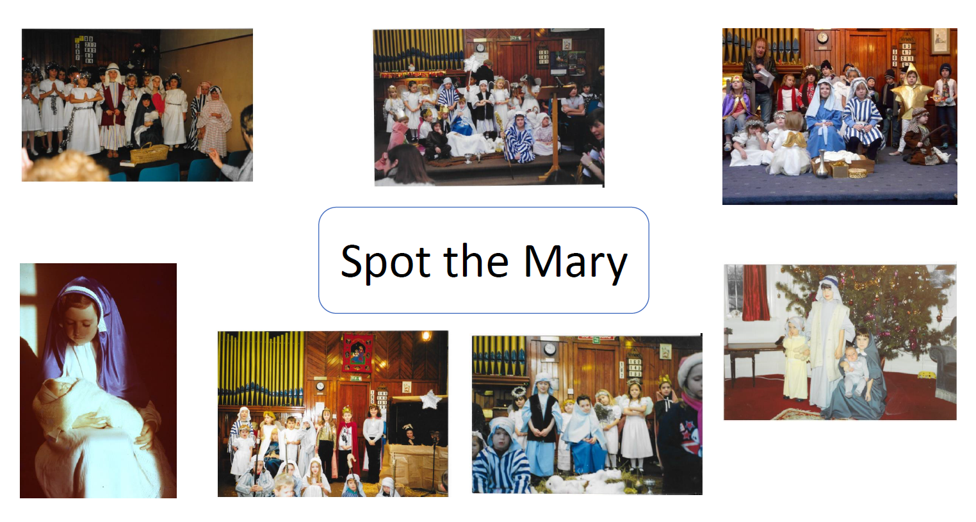

Answers to Dingbats:
1 Midnight Mass, 2 Mixed Nuts, 3 Snowball, 4 Mince pies, 5 Turkey Leftovers, 6 Frankincense, 7 Festive Season, 8 White Christmas, 9 Peace on Earth, 10 Season’s Greetings, 11 Twelfth Night, 12 Kisses under the Mistletoe, 13 Opening Presents, 14 Wrapping paper, 15 Tinsel

Answers to Christmas Quiz
1 Caesar Augustus. He ordered the people to go back to the city of their forefathers. Joseph’s family was from Bethlehem. Luke 2:1.
2 False. As in the previous answer, they went not because an angel told them or because a star led them. They were obedient to the established governmental authority.
3 The Bible does not say how they went from Galilee to Bethlehem. It was an 80 mile trip for them. It is likely that they rode some type of animal, but the Bible gives no details. It is commonly depicted that Mary rode a donkey while Joseph walked along side. But that is simply an artistic depiction. We don’t really know.
4 The book of Isaiah has much to say about the birth of the Saviour. If you have ever heard the oratorio by George Handel called The Messiah, you have heard many direct quotes from the book of Isaiah concerning the birth of Christ.
5 At least 3 angelic announcements for the birth of Christ and 1 for the birth of John. For Christ an angel appeared before Mary and Joseph individually and a multitude of angels spoke to the shepherds. For John’s birth announcement in Luke 1 Gabriel appeared before John’s father to announce the birth of John the Baptist. Matthew 1:20-24; Luke 1:11-20; Luke 1:26-38; Luke 2:9-15.
6 An angel in Matthew 1:21. The Bible does not say that this was Gabriel; however, it is assumed to be him since he was the one specifically mentioned as the messenger to Mary and Zacharias in Luke 1.
7 Jesus, Emmanuel, the Christ, Wonderful, Counsellor, the Mighty God, the Everlasting Father, the Prince of Peace. Isaiah 9:6; Matthew 1:21, 23.
8 Jesus means Saviour and Emmanuel means God with us. Jesus is the same name as the Old Testament name Joshua which also means Saviour. Matthew 1:21, 23.
9 The shepherds followed the instructions of the angels in Luke 2:9-15. The wise men followed the star to find the place where Jesus was. Matthew 2:1, 2.
10 Technically angels are never said to “sing” in the Bible. Each time they appear they only speak. However, to answer the question, the angels praised God with these words: “Glory to God in the highest, and on earth peace, good will toward men.” Luke 2:14.
11 A baby, wrapped in swaddling clothes, lying in a manger. Luke 2:12.
12 The Bible does not say how many wise men there were. Tradition says there were three because of the three gifts. There are even names given to the three wise men in different countries and cultures, but we don’t really know their names. It is also very likely there were many more than just three.
13 So that he could worship the child. But we know that his intentions were far from worship. Matthew 2:11-18.
14 It is certain that Jesus was somewhere between a month old and a couple of years old. The wise men saw His star at his birth and began following it. If the journey was 500 miles from Persia and Mesopotamia (around modern day Iraq) then it would have taken at least a month. By the time they arrived Jesus and His family had moved into a house. Later in the story Herod ordered all the children aged 2 years and younger to be killed. Therefore, Jesus was at least a month old and not yet 2 years old. Matthew 2:9-18.
15 Gold, frankincense and myrrh. Matthew 2:11.
16 This was Herod. He ordered all the children in Bethlehem and the outlying areas who were 2 years old and younger to be killed. However, Jesus and His family had already moved to Egypt (Matthew 2:13).
17 In the New Testament accounts of Christ’s birth there is no mention of any animals. However, Isaiah 1:3 could be a prophecy talking about at least a donkey seeing the crib of his Master (God). It could allude to the fact that an ox was there too. If a bunch of shepherds were there, one would assume sheep would have been present. But there is no definite list of animals mentioned in the Bible.
18 The Bible does not say. Nor does it even say that they were inhospitably turned away from an inn. It just says there was not room in the inn at Bethlehem. There may have been many hundreds of people camping in the streets and countryside during the mandatory census. Luke 2:7.
19 Simeon. Luke 2:25, 26.
20 Neither Mark nor John tell the story of the birth of Christ.

Answers to Mary Quiz: see Heather

